Course Evaluations – Reports
- Log into ONCE by visiting courseevaluations.yorku.ca
- Click on the reports heading
- Select: Section Level Evaluation Results

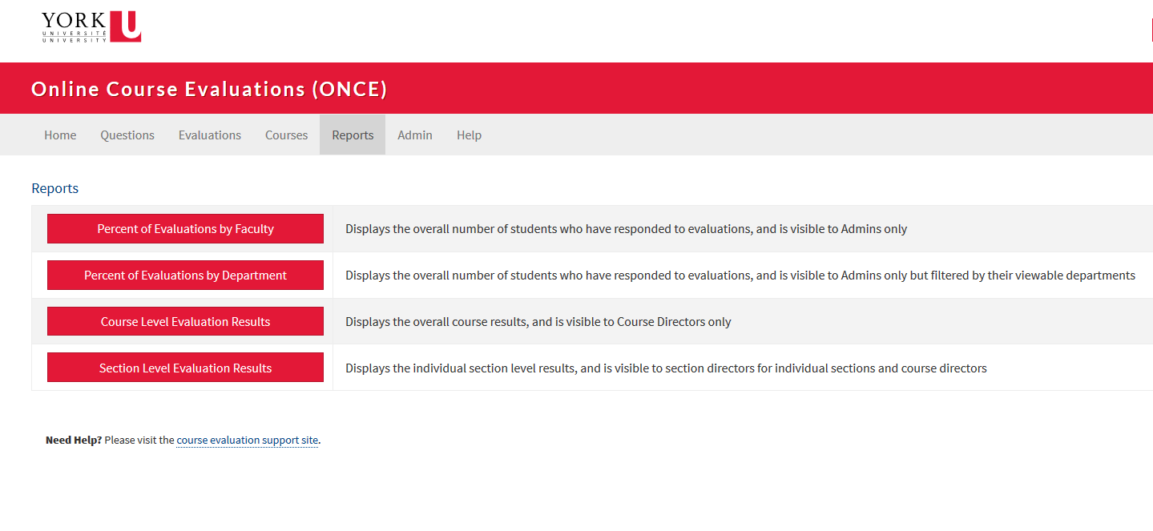

Section Level Evaluation Results
Select:
- Faculty
- Department
- Course Number
- Start Term and End Term
- Click Filter Results
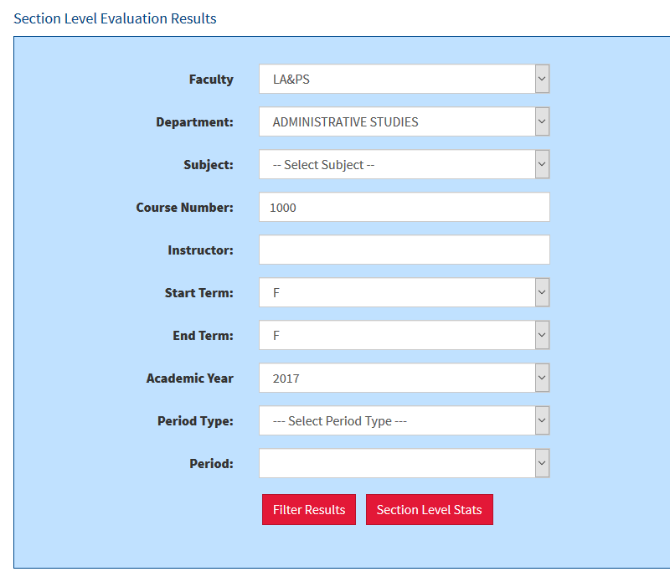

Downloading Numeric Results Report
- Find the section that you would like to retrieve results
- In the Results Column, select Numeric
- Select Instructor
- Filter Results
- Download Results as: PDF
- Rename file
- Save file
Downloading Essay Results Report
- Find the section that you would like to retrieve results
- In the Results Column, select Essay
- Select Instructor
- Filter Results
- Download Results as: PDF
- Rename file
- Save file

Results cannot be retrieved until final grades are released.

